bac-000016-IH
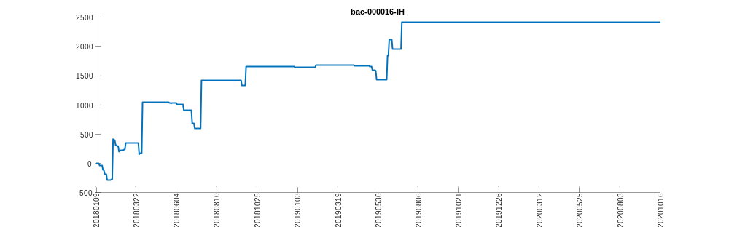
bac-000300-000016
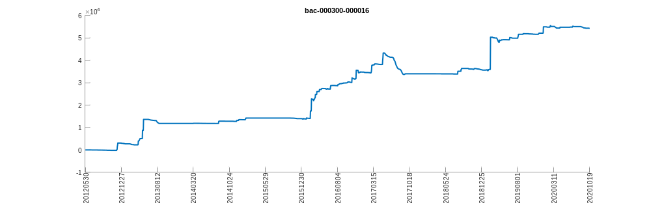
bac-000300-000905
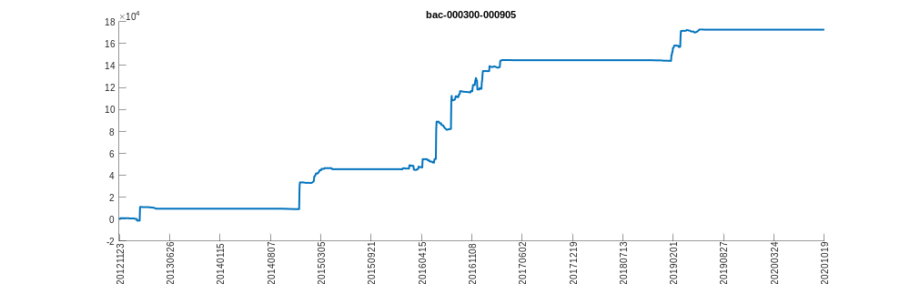
bac-000300-IF
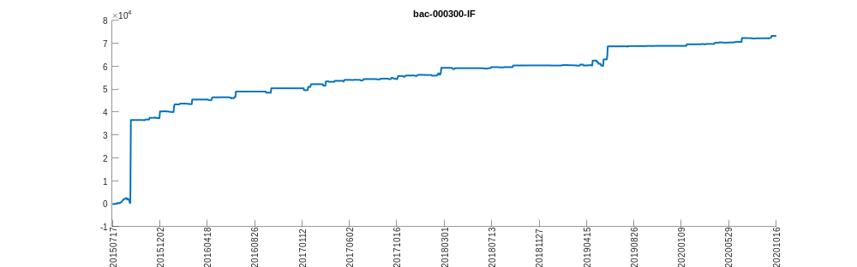
bac-000905-000016
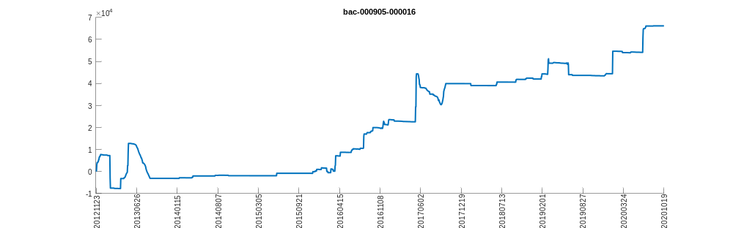
bac-000905-IC
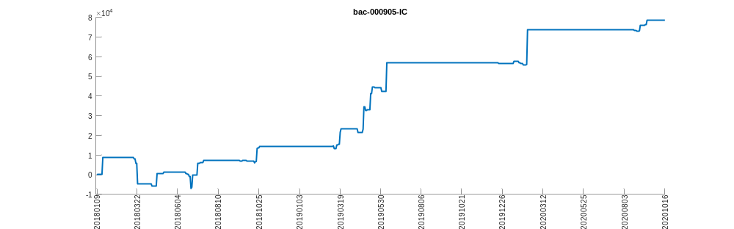
bac-IC-IH
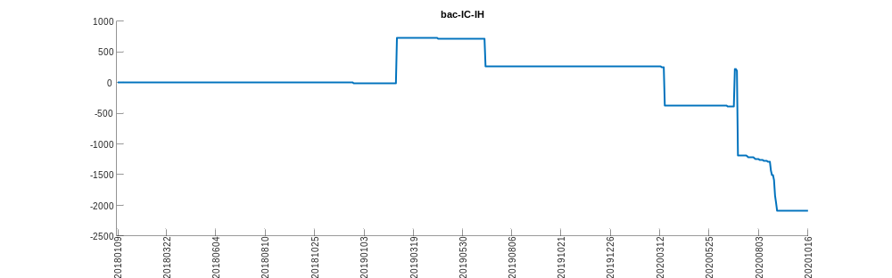
bac-IF-IC
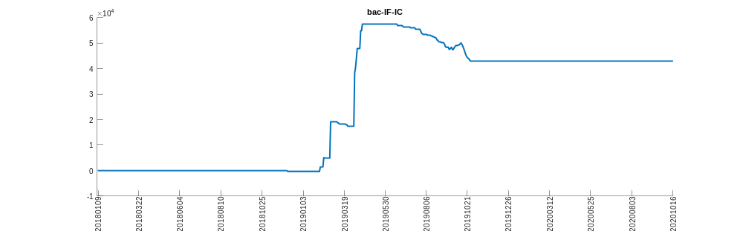
bac-IF-IH
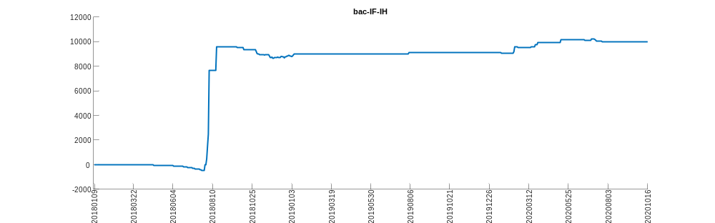
bac-SPY-QQQ
